Wang Dong Xu 王东旭
The Capriccio of the Mountain Folk Song 山谣随想
Errata List

*** All issues marked in pink. 所有问题都用粉红色标记

Some additional possible errors have been found.

Errata for Version 2
Bar  小节 | Instrument  乐器 | Issue  问题 | Answer  答案
25 (and others) | Perc I (Zhongguo Dagu) | Some notes are above/below line. Intentional or error? | Error,should be on line all,thanks
122-23 | Suonas | Added some missing dynamics based on the context. Are these what you intended? | Gaoyinsuona is correct,  ZYSN and DYSN see the score.
192-94 | Strings | Added some possible missing dynamics. Please let me know if incorrect. | Yes,no problem
193 | Winds | Should there be an ending dynamic here? | Yes,should add ending dynamic(mf),and I want to add ending note at third beat, I marked the BD and QD on the socre，orthers are same，thanks
222 | All | mf has been added for consistency. | Ok,no problem
224 | DYSh | Added possible missing decresc. | Ok,no problem

FROM PREVIOUS VERSION - ALL DONE

General changes include 一般变化包括:
- Font and format changes, including use of small time signatures, as agreed by SCO. 字体和格式的改变，包括使用小拍号，经SCO同意。
- Extending of trill line for the note duration. 延长音符时长的颤音线。
- Extending slur to the end of a tied note. 将连线延伸到连音符的末尾。
- Added English names/text for instruments. 新增乐器英文名称/文字。
- Added missing fermatas to other parts. 为其他部分添加了缺失的延长号。
- Rehearsal mark at the start has been removed. 开始时的排练标记已被删除
For such edits I have marked some of these in pink but haven’t described them in the errata list below. 对于此类编辑，我已将其中一些标记为粉红色，但未在下面的勘误表列表中对其进行描述。

Errata from Version 1
Bar  小节 | Instrument  乐器 | Issue  问题 | Answer  答案
All  全部 | All  全部 | For the grace notes – are these acciaccaturas? (In which case I would add the slash and also slur them to the main note.  对于装饰音—这些是短倚音吗？（在这种情况下，我会添加斜线并将它们连线到主音符上。） | Yes，these are acciaccaturas.  是的，都可以处理为短倚音
1 | All  全部 | Removed Rehearsal A, given that it is the start of the piece. Is that okay?  删除了排练标记 A，因为它是乐曲的开始。可以吗？ | Yes, the rehearsal number at the beginning should be removed.  Rehearsal number A is changed to start at bar 25, rehearsal number C is changed to B, and then the rehearsal number position remains the same, but the serial number must be in advance.
17 | Di, Suona  笛，唢呐 | I added (mf) since the rest of the orchestra goes to this dynamic. I understand the next dynamic for these notes is f so I’d like to check if you intend for the crescendo to continue till the f (beat 2).  我添加了(mf)，因为管弦乐队的其他成员都参与了这种动态。我知道这些音符的下一个动态是f，所以我想检查一下您是否打算让渐强持续到f（第2拍 ）。 | Should add mf
24 | Winds  管乐 | Added mf here to match plucked strings.  此处添加了 mf 以匹配弹拨乐。 | Yes, ok
30 | Percussion  打击 | What’s the dynamic here?  这里有什么力度？ | All percussions，please add f
68-69 | Bass  低音提琴 | I changed the 1st note of bar 69 from A natural to A#. Is this correct?  我将第 69 小节的第一个音符从 团圆还原A 更改为 A#。它是否正确？ | Yes, correct
112 | Winds  管乐 | Should these also be ff ?  这些也应该是ff吗？ | Yes
128 | Upper strings  胡琴 | Should these notes also have a gliss. line like the previous two bars?  这些音符是否也应该像前两个小节一样有滑奏线？ | NO, no need gliss
140 | Harp  竖琴 | Is it okay if we remove harp pedalling text/diagram and pedal changes as these can be in the parts but not needed in the score.  如果我们删除竖琴踏板文本/图表和踏板更改，可以吗？因为这些可以在分谱中，但在总谱中不需要。 | Yes, ok
146-47 | Dizi solo  笛子独奏 | Is there supposed to be one slur for this entire figure like this:  整个数字是否应该有一个像这样的连线：  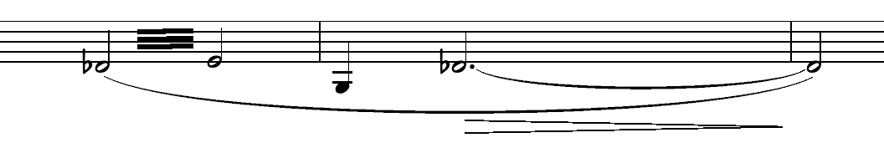  Or something more like this:  或者更像这样：  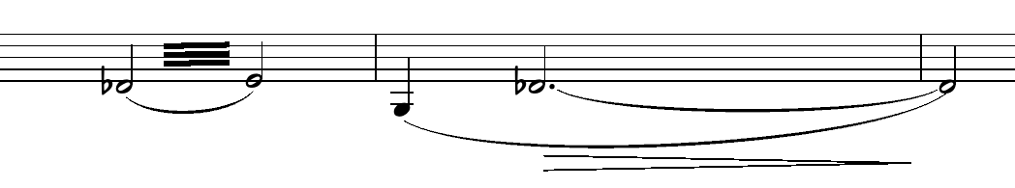 | Yes, I think the later one will be better.
204-05 | Harp  竖琴 | Added beats for clarity.  为了清晰起见添加了节拍。 | Yes, ok
206 | Perc III  打击 III | Added ff here  在这里添加了ff | Yes, ok
228 | Perc II  打击 II | Can I confirm that 小钟琴= Kalimba  我可以确认小钟琴是卡林巴吗 | 小钟琴=Glockenspiel
255 | Dizi solo  笛子独奏 | Does this trill continue to the end of the next note?  这个颤音是否会持续到下一个音符的末尾？ | NO, just to the end of the bar 255
264-75 | Perc I  打击 I | Moved the notes up to be at the line. Was previously below the line.  将音符向上移动到该行。之前是低于线的。 | Yes, ok
275 | Dizi solo  笛子独奏 | Changed the tie from the tremolo to the next note to a dotted tie, given that the next note is on a new breath. I can also make it a bracketed tie, let me know if you have a preference!  鉴于下一个音符再一次呼吸，将颤音与下一个音符的连接改为点连接。我还可以把它做成括号领带，如果您有偏好，请告诉我！ | Thank you, I think dotted tie is better.
291 | Erhu  二胡 | Changed the grace note to acciaccatura to match Gaohu.  将装饰音更改为短倚音以匹配高胡。 | Yes, ok
292 | GYSh  高音笙 | Adjusted crescendo to match other instruments.  调整渐强以匹配其他乐器。 | Yes, ok
299 | Cb.  低音提琴 | Do you want a crescendo here like the other strings?  您想要这里像其他弦一样渐强吗 | Yes, it should add cresc.
301 | Dizi solo  笛子独奏 | Should this note also be sf?  这个音也应该是sf吗？ | Yes, sf is correct.

